University Of Engineering and Technology, Lahore
Computer Engineering Department

Course Name: Programming Fundamentals | Course Code: CMPE-112L
Assignment Type: Lab Tasks | Dated: 18 May 2026
Semester: First | Session: 2026 Spring
Lab/Project/Assignment #: 1 | CLOs to be covered: CLO 4
Lab Title: Exception Handling | Teacher Name: Hafiz Muhammad Mubashar
Lab Evaluation:

CLO4 | Apply appropriate programming techniques to create executable programs to solve well defined problems
CLO4 | Level1 | Level2 | Level3 | Level4 | Level5 | Level6
(5)
Total |  |  |  |  |  | /5
Rubrics for Current Lab Evaluation
Scale | Marks | Level | Rubric
Excellent | 5 | L1 | Submitted all lab tasks, BONUS task, have good understanding.
Very Good | 4 | L2 | Submitted the lab tasks but have good understanding
Good | 3 | L3 | Submitted the lab tasks but have weak understanding.
Basic | 2 | L4 | Submitted the lab tasks but have no understanding.
Barely Acceptable | 1 | L5 | Submitted only one lab task.
Not Acceptable | 0 | L6 | Did not attempt
LAB No 1
Exception Handling
Lab Goals/Objectives:
• To understand the purpose and execution flow of Exception Handling in Python.
• To learn how to intercept runtime errors using try and except blocks to prevent programs from crashing.
• To handle unexpected user input safely and ensure remaining application code continues executing.

Equipment Required:

* Computer/Laptop
* Python 3.14
* VS Code or pycharm

Theory:

An exception is an error that occurs during the execution of a program. If left unhandled, an exception immediately halts the script and displays a traceback error.

Lab Work:

Task 1: Handling Invalid Type Casting Input
try:
b = int(input("Enter a number:"))
print(b)
except:
print("invalid")
print("Hello World")

Result:
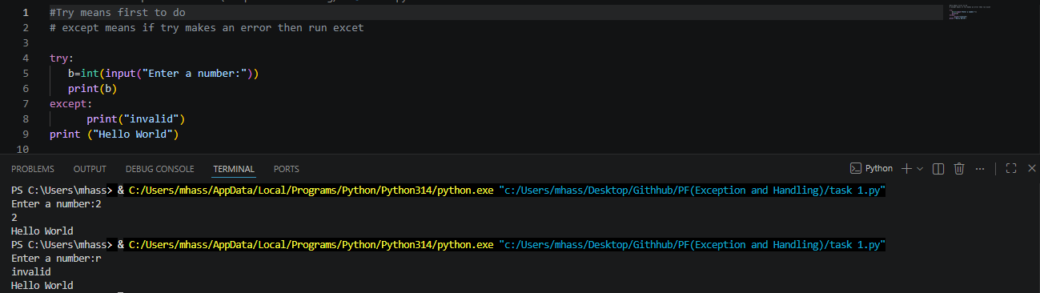

Conclusions:
This lab successfully demonstrates the implementation of defensive programming using Exception Handling in Python. By wrapping unpredictable operations—such as user-driven type casting—inside a try-except structure, we observed how to prevent unexpected string inputs from causing a script crash, thereby keeping the trailing logic safe and functional.

